LABORATORY EXERCISE 2

ADVANCED TABLE DESIGN & RELATIONSHIPS

Learning Objectives
By the end of this laboratory exercise, students should be able to:
- To move beyond simple single-table databases and accurately model real-world data connections by practically implementing One-to-Many and Many-to-Many relationships within an SQL database.
- To understand and utilize the FOREIGN KEY constraint as a fundamental mechanism to prevent orphaned records and ensure that relationships between tables remain consistent and valid.
- To reinforce data quality and business logic through the use of UNIQUE and NOT NULL constraints, ensuring the accuracy and reliability of the stored information.

Prerequisite student experiences and knowledge
Students are expected to have a foundational understanding of the following concepts:
- Primary Keys
  - The purpose of a unique identifier for each record in a table is to ensure that it is unique.
- Foreign Keys
  - A field in one table that uniquely identifies a row in another table, establishing a link between them.
- Cardinality in ER Diagrams
  - The ability to interpret and draw Entity-Relationship Diagrams, explicitly recognizing the symbols and notation for one-to-many (1:M) and many-to-many (M:N) relationships.

Background
This lab focuses on translating these conceptual relationships into a physical database schema. The Foreign Key (FK) constraint is the primary tool that enforces referential integrity. This means the database will prevent actions that would break these links. To resolve a many-to-many relationship, we create a junction table (or associative entity), which breaks the M:N relationship into two separate One-to-Many relationships.

Materials/Resources
- dbGate
- Personal Computer with Internet Access
- XAMPP/WAMP/LAMP server installed
Laboratory Activity
Using your `DB_Lastname` database, perform the following steps.
- Create the `Instructors` Table
  - This table will store information about each Instructor. The `instructor_id` is an auto-incrementing primary key, ensuring each Instructor has a unique ID.
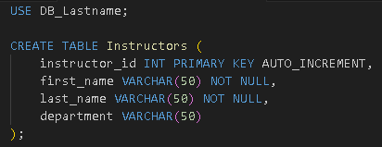
- Alter the Courses Table to Add a Foreign Key
  - This establishes a One-to-Many relationship.
    - One Instructor can teach Many Courses. The instructor_id in the Courses table is a foreign key that points to the `Instructors` table.
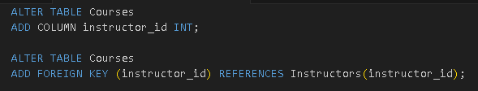
Note: Before adding the FK, ensure the `Courses` table exists. If it doesn't, you must create it first.

- Create the Enrollments Junction Table
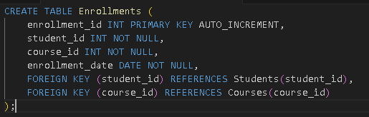
  - This table resolves the Many-to-Many relationship between Students and Courses. Its composite primary key (or a unique enrollment_id) ensures a student cannot be enrolled in the same course more than once. The `student_id` and `course_id` are foreign keys.

Output / Results
- Screenshot of Instructors Table Schema
  - The four columns are `instructor_id` (PK, AI), `first_name`, `last_name`, and `department`.
- Screenshot of Courses Table Schema (Altered)
  - Highlights the newly added `instructor_id` column and shows the foreign key constraint listed in the table's relations. The "Foreign Keys" tab should show a constraint where `instructor_id` references `instructors(instructor_id)`.
- Screenshot of `Enrollments` Table Schema
  - Shows all columns: `enrollment_id` (PK, AI), `student_id`, `course_id`, `enrollment_date`.
  - The "Foreign Keys" tab should show two constraints:
    - `student_id` references `students(student_id)`
    - `course_id` references `courses(course_id)`
- Screenshot of Database EER Diagram
  - A visual diagram showing all four tables (`Students`, `Courses`, `Instructors`, `Enrollments`) with connecting lines illustrating the one-to-many relationships. This clearly shows the `Enrollments` table as a junction between `Students` and `Courses`.

QUESTIONS:
- What is the purpose of the Enrollments table?

- What does the FOREIGN KEY constraint do if you try to delete a Student who is referenced in the Enrollments table?

- How would you design a table to store a student's different phone numbers?Why?

Output / Results

Conclusion

